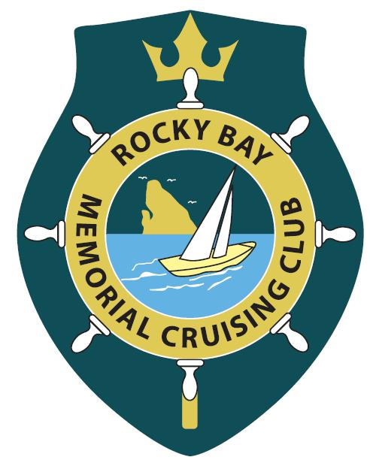
ROCKY BAY MEMORIAL CRUISING CLUB INC

www.rockybaycruisingclub.co.nz
P O BOX 283
OSTEND

WAIHEKE

ISLAND

Hi Team – Welcome to Autumn!!!!!!

To kick of the season the RBMCC Pirates set up the plank for the Waiheke Wharf to Wharf challenge - a BIG THANKS to Mark Stratton for bringing the pirates together!! A lot of fun had by all manning the water stop. Another successful national event held on Waiheke Island drawing runners from far and wide.
In conjunction with that event RBMCC had its first inaugural Happy hour at the club house Pohutakawa lane with a Top cruiser being celebrated (St Patrick’s Day) a good reason to socialise and meet people, sausage sizzle a blaze with a range of snacks, green punch (which went down very well) and plates brought by attendees with around 20 in attendance to kick start the happy hour idea. Cheers to everyone who could make it and to those who couldn’t, there is always next month!

CLUB SUBS

Club subs are on everyone’s mind with a final day of 2nd of April being last day for payment. Outstanding past and present fees (subs and lockers) would be appreciated. A BIG applause to everyone who has updated their membership, only a few outstanding.

UP COMING EVENTS

Easter Weekend is THE time to put aside for a Family fun fishing day (Competition details attached), Followed by the PRIZE giving at 1pm at Mary Wilson Park, Omiha also aligned with the RBMCC Annual Club Picnic!!! So Club members (who do not wish to get up on an Easter Weekend at 0600 to go fishing) bring yourselves down after 1pm for a BBQ, refreshments and a socialise. Bring a plate would be appreciated.
This Photo by Unknown Author is licensed under CC BY-NC-SA
This day will also be the day you catch a giant fish and make you want to enter it in the club annual Fisho of the Year competition, last day for entry into this league of fishing hero’s.
Next amazing happy hour will be announced as soon we come back from Ireland lol.

WEB SITE

Please look at it regularly to keep in touch with club info and contact the RBMCC Secretary debbiehague9@gmail.com to comment or sell an item.

Safe boating

Steven McElligott

Commodore

